**Famous Linked Server setup**

**General Settings**

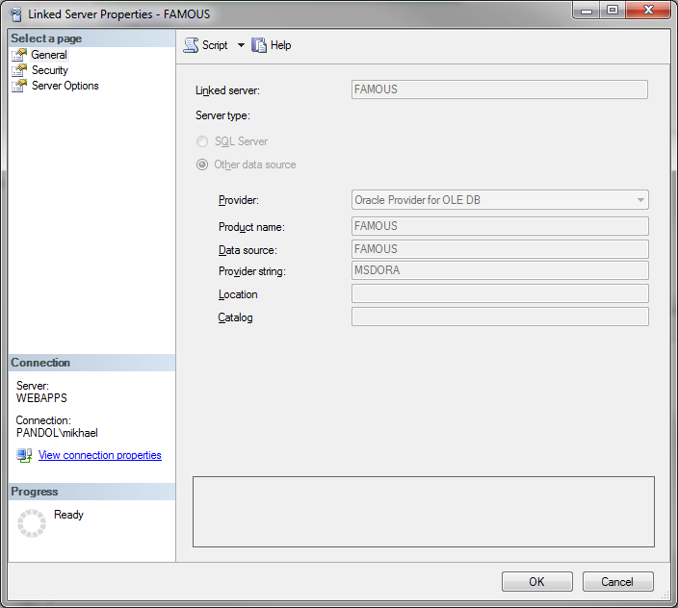

**Security Settings:**

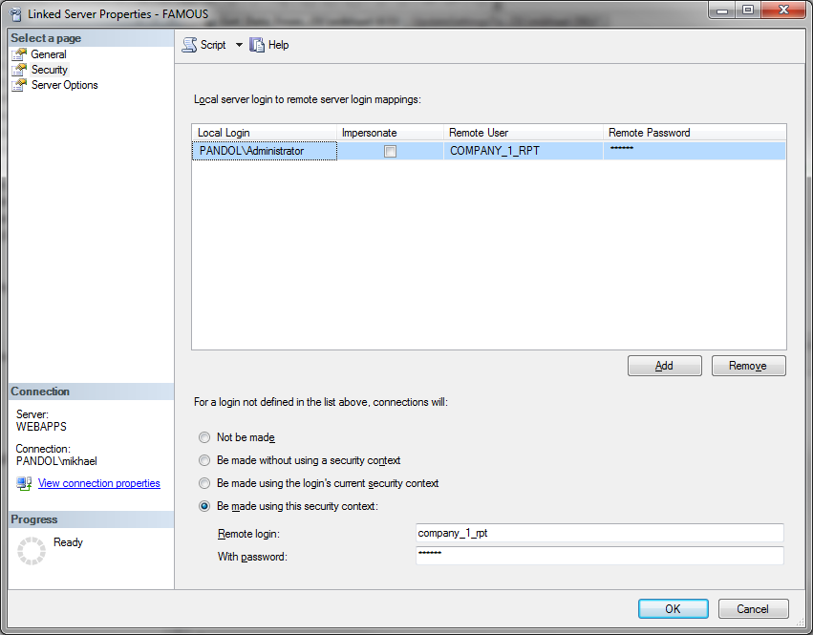

Password for company_1_rpt is “famous”

**Server Options:**

